Ivey Center for the Cultural Approach to History

Lesson Name
Go West….But at What Cost?

Author
Margaret Koger

Grades | Subject | Topic
Suitable for Grade 5 | Social Studies | Westward Expansion and the Impact on the American Indian

Overview/Summary:
BACKGROUND:
This information is provided for the teacher in an effort to build background knowledge and context.

According to the National Endowment for the Humanities, children’s literature, movies, and other media often perpetuate generalized stereotypes, whether positive or negative, in their representations of Native American people. Teaching children about the First Americans is necessary to understanding the history of this country. This should be taught in an accurate historical context that emphasizes their continuing presence and influence within the United States.

Recent findings have indicated that children today are not growing up surrounded by the fictionalized Old West television and movie images of the 20th century. As a consequence, teachers will hopefully encounter among their students fewer pre-conceived, stereotypical notions about Native Americans. Because primary grades typically study Native American units, students’ prior knowledge by the 5th grade will often include an awareness of the original variety of native tribes in the pre-Columbian Americas.

BACKGROUND: (continued)
A number of students, however, may not be aware that many tribes continue today and have preserved their languages, art, and religious traditions. In an effort to help increase this awareness, the lesson incorporates the YouTube video suggested by the tribes. “Looking Toward Home: An Urban Indian Experience”
https://www.youtube.com/watch?v=sQMNyo3SfKw

Though in no way complete, this lesson should be a step in helping to create an awareness of the tribes in the 21st century, while still focusing on the Georgia Performance Standards for 5th grade.

Unit Name | Estimated Time Needed
What became of the American Indian tribes when their homelands became the United States? | 1-2 days-for each lesson

State/Common Core Standard, Grade Level & Description
Standard Number |  | Detailed description of each standard.
5th Grade Georgia Performance Standard:  SS5H3 The student will describe how life changed in America at the turn of the century | 5 | SS5H3 The student will describe how life changed in America at the turn of the century.  e. Describe the impact of westward expansion on American Indians; include the Battle of the Little Bighorn, the Battle of Horseshoe Bend (Mvskoke Battle) and the relocation of American Indians to reservations.

NCSS Theme | Description
Theme Number | Detailed description of each NCSS theme
1 | Culture
2 | Time, Continuity, and Change
3 | People, Places and Environment
5 | Individuals, Groups, and Institutions

The Cultural Approach Category | Description
Category | Detailed description of each Category that is a focus of this lesson.
Social | How did westward expansion change the social aspect of the American Indian?
Political | How did the political climate negatively affect the American Indian?
Intellectual | How and why were the American leaders able to justify the Indian removal to reservations?
Economic | How did westward expansion impact the economic development of the American Indians?

Handouts/Materials/Textbook Pages/Web Links
List all of the materials in the lesson. List pages in textbooks and online links.
5th Grade
A Book of Americans by Rosemary and Stephen Vincent Benet
http://ccss5.watchknowlearn.org/Video.aspx?VideoID=36799&CategoryID=3532
http://www.nativehistoryassociation.org/removal.php
http://www.loc.gov/teachers/classroommaterials/presentationsandactivities/presentations/immigration/native_american.html
http://www.powersource.com/cherokee/history.html
http://www.pbs.org/weta/thewest/resources/archives/six/bighorn.htm
https://www.youtube.com/watch?v=sQMNyo3SfKw

Image | Description | Citation | URL
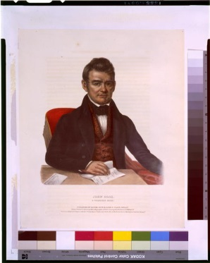 | John Ross, a Cherokee chief | Title: John Ross, a Cherokee chief / drawn, printed & coloured at the Lithographic & Print Colouring Establishment, 94 Walnut St | http://www.loc.gov/pictures/item/94513504/
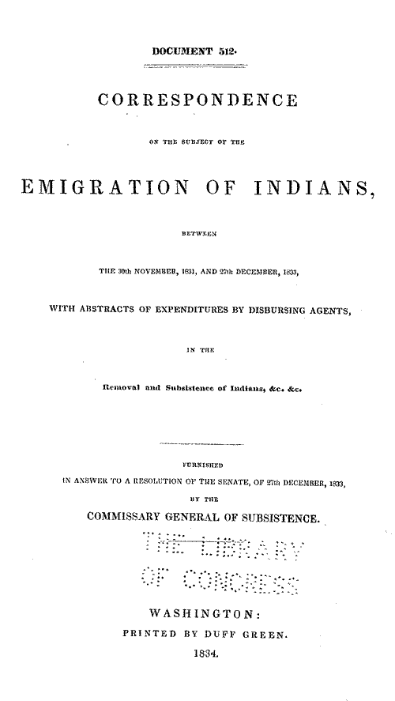 | Documents from 23rd Congress, 1833-1835 | A Century of Lawmaking for a New Nation: U.S. Congressional Documents and Debates, 1774 - 1875  United States Serial Set, Number 244 | http://memory.loc.gov/cgi-bin/ampage?collId=llss&fileName=0200/0244/llss0244.db&recNum=0
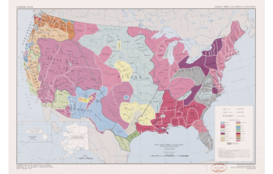 | National atlas. Indian tribes, cultures & languages : [United States] | Reston, Va. : Interior, Geological Survey, 1991. | http://www.loc.gov/resource/g3701e.ct003648r/

Guiding Questions
What should students know or understand at the completion of the unit or lesson?
- What became of the American Indians who were removed from their homelands?
- How do political policies shape our nation?
- Is force necessary to inforce political policy?
- Did anyone benefit from the removal policy?

Lesson Objectives:

- Students will be able to describe President Andrew Jackson’s Indian policy, which was to push native tribes westward and give their lands to European American settlers.
- Students will be able to describe the events leading up to the Battle of Little Big Horn and the results that followed
- Students will be able to compare and contrast life on a reservation to that of life before the relocation

Indicators of Achievement
List all of the important indicators of achievement (important people, places, and events) and vocabulary that students will need to know at the conclusion of the lesson.
Reservation
Policy -Indian Removal Act 1830’s
Treaty
Dawes Act (1887)

Sparking Strategy/Warm-Up
Sparking Strategy (Lesson introduction)
Distribute copies of the poems by Meikko Lewis “The Trail of Tears”, “The Journey” and “Colors” (Copies included)
Read as a group and then have students do a journal entry or drawing to share their views on the poem.
Lesson Procedures
In a numerical list provide a step by step outline of the lesson. Include questions you will ask the students and material you will use.
Outline (Steps also clarified in Guide Sheet)
- The lesson will begin with the question: “What became of the American Indian tribes when their homelands became the United States?”
- Using local resources, invited a Muscogee tribal member to the class
- Have the class read aloud selections from If You Lived with the Cherokee.
- As a class brainstorm the question above, and then have students begin an exploration to find evidence for an answer. Students should consider the following:
  - Defining the term “policy”. 
  - What is a policy? (Synonyms include: procedure, program, practice, system, approach.)
  - Begin with school policies (all children must attend school, dress codes, etc.) to establish the concept, and then move to other areas such as city traffic laws and library policies.
  - Conclude with discussion of federal government policies, such as the welfare system, support for higher education through student loans and grants, federal interstate highway system, federal environmental regulation. –Jackson’s Indian Removal Policy – read description as a class. (Included)
  - The native experience on the Trail of Tears. Did anyone benefit from the removal policy? Who? How?
- Students respond to the readings – Students write a one-page paper describing their position on this policy. Would they have supported or opposed it had they lived in the 1830’s? Why?

Day 2:
Life on an Indian Reservation in the 21st Century
1.Share excerpts from “Looking Toward Home: An Urban Indian Experience”
https://www.youtube.com/watch?v=sQMNyo3SfKw
- Discuss excerpts as appropriate for age level.
- Discuss the difference and similarities between Indians in the 20th and 21st century.

Differentiation
Think about students’ skill levels, intelligences, and learning styles.
For the advanced learner, have the student write a position paper from both sides of the arguments

Evaluation
- Rubric for position papers

Citations (as needed)
http://www.loc.gov/teachers/classroommaterials/presentationsandactivities/presentations/immigration/native_american.html
https://www.youtube.com/watch?v=sQMNyo3SfKw

Contributor’s comments: Thank you so much for this valuable feedback. I have tried in the revision to add information about tribes in the 21st century. Being able to help in some small way to create lessons that are both historically accurate and honor the legacy of the tribes is both a privilege and a learning opportunity for me as an educator.

