Ivey Center for the Cultural Approach to History

Lesson Name
Lesson 1: First Grade
American Indian Heroes

Author
Margaret Koger

Grades | Subject | Topic
Suitable for grade 1 | Social Studies | Tomochichi, chief of the Yamacraw Indians  Mary Musgrove

Overview/Summary:
BACKGROUND INFORMATION FOR THE TEACHER:
This information is provided for the teacher in an effort to build background knowledge and context.

American Indian cultures have existed in this area for thousands of years. Scientists believe that a large population of Paleo-Indians settled in the southeastern region of what is now the United States after following large mammals, such as mastodons, through northern areas of our continent. For hundreds of years, they lived a nomadic existence as hunters and gatherers. Eventually they created permanent towns and utilized temporary camps while hunting and harvesting seasonal crops.

Around 1000 AD, the Mississippian culture evolved. These societies had hereditary rulers, structured religions, political structure, and a complex system of beliefs and economic system based on communal ideals. This American Indian population declined with the arrival of the Spanish explorers in the 16th century. The explorers enslaved and killed some Indians, but even more deadly were the European diseases they introduced.

After the Spanish invasion, the American Indians began to rebuild their culture. Although farming and hunting continued, the time of large villages, elite rulers, and priests was over.

When European settlers began to arrive in the 1700s, the largest American Indian tribe in the area was a Muskogean tribe (called Creeks by the Europeans).These Indians carried on many native traditions, but also integrated European trade goods into their daily life. They began raising livestock and building log cabins as a result of their contact with European settlers.

Many southeast American Indians were forced to give up their land and resettle in Oklahoma during the 1830s. Many of them died on the way as they followed the Trail of Tears. This unit of study seeks to both inform and pay tribute to these noble people.

According to the National Endowment for the Humanities, children’s literature, movies, and other media often perpetuate generalized stereotypes, whether positive or negative, in their representations of Native American people. Teaching children about the First Americans is necessary to understanding the history of this country. This should be taught in an accurate historical context that emphasizes their continuing presence and influence within the United States.
In this unit of study, students will be introduced to the rich culture and heritage of the Creek (Muscogee) Creek Nation. Students will gain an understanding and appreciation for these first Americans who once occupied the lands where Ft. Benning now stands. Using the Cultural Approach to History, students will examine this rich nation through analyzing the six dimensions of culture (Politics, Religion, Aesthetics, Intellectual Developments, Social Relations, and Economics) in a given place and time.
Throughout the research, it has been noted that the first Americans are known by several different names. The terms Native American, Native People, and American Indians seem to be used interchangeably. Of the three, most sources recognize that the majority prefer the term American Indian. However, the overwhelming preference seems to be to use the unique name of the tribe. In creating these plans, an attempt has been made to respect this preference. However, because the research has revealed that the other terms are also acceptable, the three terms will be used interchangeably as well.

Unit Name | Estimated Time Needed
American Indian Heroes | 1-2 days-for each lesson

State/Common Core Standard, Grade Level & Description
Standard Number |  | Detailed description of each standard.
1st Grade Georgia Performance Standard  SS1H1 The student will read about and describe the life of historical figures in American history. | 1 | a. Tomochichi and Mary Musgrove  b. Describe how everyday life of these historical figures is similar to and different from everyday life in the present (food, clothing, homes, transportation, communication, recreation).
SS1CG1 The student will describe how the historical figures in SS1H1a display positive character traits |  | - Fairness, respect for others, respect for the environment, conservation, courage, equality, tolerance, perseverance, and commitment.

NCSS Theme | Description
Theme Number | Detailed description of each NCSS theme
1 | Culture
2 | Time, Continuity, and Change
3 | People, Places and Environment
5 | Individuals, Groups, and Institutions

The Cultural Approach Category | Description
Category | Detailed description of each Category that is a focus of this lesson.
Social | How did Tomochichi and Mary Musgrove show respect and tolerance to the explorers and the environment?
Religious | How did Tomochichi show respect for the differences in religious beliefs?
Economic | How did the arrival of Ogelthorpe impact the America Indians?

Handouts/Materials/Textbook Pages/Web Links
List all of the materials in the lesson. List pages in textbooks and online links.
https://www.youtube.com/watch?feature=player_embedded&v=ruyAbZLpXck
https://www.youtube.com/watch?v=7U1Bd-Jv_og&feature=player_embedded

Image | Description | Citation | URL
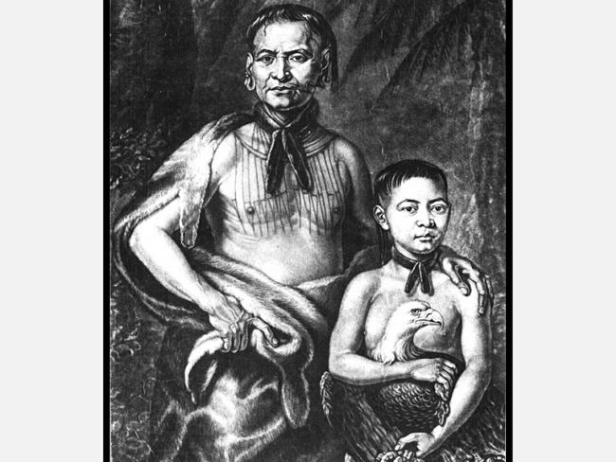 | Tomochichi | http://www.georgiaencyclopedia.org/articles/history-archaeology/tomochichi-ca-1644-1739 | http://www.georgiaencyclopedia.org/articles/history-archaeology/tomochichi-ca-1644-1739
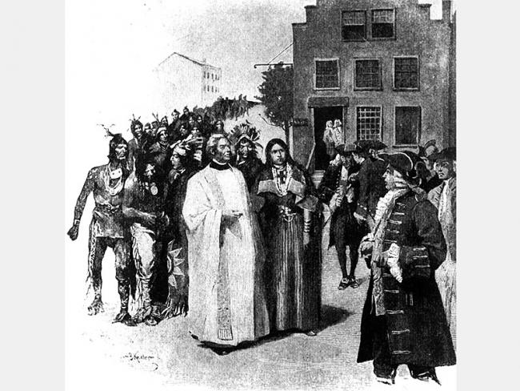 | Mary Musgrove | Frank, Andrew K. "Mary Musgrove (ca. 1700-ca. 1763)." New Georgia Encyclopedia. 06 January 2016. Web. 16 February 2016. | http://www.georgiaencyclopedia.org/articles/history-archaeology/mary-musgrove-ca-1700-ca-1763
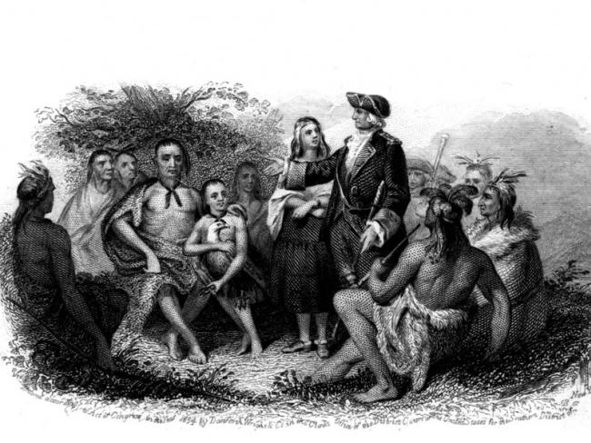 | James Oglethorpe | Jackson, Edwin L. "James Oglethorpe (1696-1785)." New Georgia Encyclopedia. 06 January 2016. Web. 14 February 2016. | http://www.georgiaencyclopedia.org/articles/history-archaeology/james-oglethorpe-1696-1785

Guiding Questions
What should students know or understand at the completion of the unit or lesson?
- How did the contributions of Tomochichi help James Oglethorpe? (SS1H1a)

- How are their contributions beneficial to us today? (SS1H1a)

• How did Mary Musgrove and Tomochichi demonstrate positive character traits of honor and integrity? What are some examples? (SS1CG1).
• How was daily life for Tomochichi and Mary Musgrove the same as or different? How does their life differ from ours? (SS1H1b)
• Why have people’s lives changed since the time of Tomochichi and Mary Musgrove? (SS1H1b) The natural world and people around us shape what we do.
• How did Tomochichi’s knowledge of nature, people, and land help Oglethorpe and the early colonists? (SS1G1)

Lesson Objectives:

- Students will be able to identify the ways in which Tomochichi and Mary Musgrove helped James Oglethorpe
- Students will be able to describe the ways in which Tomochichi and Mary Musgrove demonstrated tolerance, bravery, fairness and respect

Indicators of Achievement
List all of the important indicators of achievement (important people, places, and events) and vocabulary that students will need to know at the conclusion of the lesson.
contributions
producers
consumers
achievement
fairness
respect
conservation
courage
equality
tolerance
perseverance
commitment
integrity
loyalty

Sparking Strategy/Warm-Up
Sparking Strategy (Lesson introduction)
Georgia Digital Storytelling Video:
https://www.youtube.com/watch?v=7U1Bd-Jv_og&feature=player_embedded

Lesson Procedures
In a numerical list provide a step by step outline of the lesson. Include questions you will ask the students and material you will use.
Outline
- Introduce the early Colonial Period and the arrival of James Oglethorpe. Show a video clip on Tomochichi https://www.youtube.com/watch?feature=player_embedded&v=ruyAbZLpXck
- After showing the video clip on Tomochichi, have students complete a Venn diagram comparing and contrasting their lives to that of his. Share these similarities and differences.
- During a class discussion, talk with students about the obstacles (hardships) that may have been faced by the early Colonists and how Tomochichi and Mary Musgrove provided help.
- Discuss how the positive character traits listed in the objectives influenced their willingness to help.
- Write a journal entry or draw a picture that reflects in the day in the life of Tomochichi or Mary Musgrove and their positive character trait.

Differentiation
Think about students’ skill levels, intelligences, and learning styles.
- For the gifted/advanced learner, have students role play being a news reporter and interviewing Mary Musgrove, James Oglethorpe, and Tomochichi
- For the learner needing extra help, have the student dictate his journal entry to an adult

Evaluation
- Teacher observation
- Check journal entries/pictures

Citations (as needed)
- http://www.georgiaencyclopedia.org/articles/history-archaeology/mary-musgrove-ca-1700-ca-1763
- http://www.georgiaencyclopedia.org/articles/history-archaeology/tomochichi-ca-1644-1739

