Ivey Center for the Cultural Approach to History

Lesson Name
Lesson 1: “Necessary Beginnings”

Author
Margaret Koger

Grades | Subject | Topic
2nd Grade | Social Studies | Muscogee Indians

Overview/Summary:
TEACHER BACKGROUND:
This information is provided for the teacher in an effort to build background knowledge and context.

American Indian cultures have existed in this area for thousands of years. Scientists believe that a large population of Paleo-Indians settled in the southeastern region of what is now the United States after following large mammals, such as mastodons, through northern areas of our continent. For hundreds of years, they lived a nomadic existence as hunters and gatherers. Eventually they created permanent towns and utilized temporary camps while hunting and harvesting seasonal crops.

Prior to the Mississippian Culture, the Archaic Culture (8,000 to 3,000 BC) and Woodlands Culture (3,000 BC to approximately 1670 AD) are important parts of the archaeological record. The Archaic Period is characterized as more of a gathering and hunting life whereas the Woodlands Period is characterized by increasing horticulture expertise and social complexity.

Beginning around 1000 AD, the Mississippian culture evolved. These societies had hereditary rulers, structured religions, political structure, and a complex system of beliefs and economic system based on communal ideals. This American Indian population declined with the arrival of the Spanish explorers in the 16th century. The explorers enslaved and killed some Indians, but even more deadly were the European diseases they introduced.

After the Spanish invasion, the American Indians began to rebuild their culture. Although farming and hunting continued, the time of large villages, elite rulers, and priests was over.

When European settlers began to arrive in the 1700s, the largest American Indian tribe in the area was a Muskogean tribe (called Creeks by the Europeans).These Indians carried on many native traditions, but also integrated European trade goods into their daily life. They began raising livestock and building log cabins as a result of their contact with European settlers.

Many southeast American Indians were forced to give up their land and resettle in Oklahoma during the 1830s. Many of them died on the way as they followed the Trail of Tears. This unit of study seeks to both inform and pay tribute to these noble people.

According to the National Endowment for the Humanities, children’s literature, movies, and other media often perpetuate generalized stereotypes, whether positive or negative, in their representations of Native American people. Teaching children about the First Americans is necessary to understanding the history of this country. This should be taught in an accurate historical context that emphasizes their continuing presence and influence within the United States.
In this unit of study, students will be introduced to the rich culture and heritage of the Muscogee Nation. Students will gain an understanding and appreciation for these first Americans who once occupied the lands where Ft. Benning now stands. Using the Cultural Approach to History, students will examine this rich nation through analyzing the six dimensions of culture (Politics, Religion, Aesthetics, Intellectual Developments, Social Relations, and Economics) in a given place and time.
Throughout the research, it has been noted that the first Americans are known by several different names. The terms Native American, Native People, and American Indians seem to be used interchangeably. Of the three, most sources recognize that the majority prefer the term American Indian. However, the overwhelming preference seems to be to use the unique name of the tribe. In creating these plans, an attempt has been made to respect this preference. However, because the research has revealed that the other terms are also acceptable, the three terms will be used interchangeably as well.

Unit Name | Estimated Time Needed
The Muscogee: The History of a Noble People | 1-2 days-for each lesson  Estimated time for unit-2 weeks

State/Common Core Standard, Grade Level & Description
Standard Number |  | Detailed description of each standard.
2nd Grade Georgia Performance Standard  The student will describe the Georgia Creek and Cherokee cultures of the past in terms of tools, clothing, homes, ways of making a living, and accomplishments. | 2 | SS2H2 The student will describe the Georgia Creek and Cherokee cultures during the Mississippian time period of the past in terms of tools, clothing, homes, ways of making a living, and accomplishments.  - Describe the regions in Georgia where the Creeks and Cherokees lived and how the people used their local resources.  - Compare and contrast the Georgia Creek and Cherokee cultures of the past to Georgians today.
Department of Defense Education Activity (DoDEA) Standard 4SS2:  Students analyze the geographic, political, economic, and social structures in the Southeastern region of the United States. |  | 4SS2.b: Examine the Southeastern Indian cultures that originated from this region and examine the main features of their art and architecture.

NCSS Theme | Description
Theme Number | Detailed description of each NCSS theme
1 | Culture
2 | Time, Continuity, and Change
3 | People, Places and Environment
5 | Individuals, Groups, and Institutions

The Cultural Approach Category | Description
Category | Detailed description of each Category that is a focus of this lesson.
Social | How did their beliefs influence and reflect their communities and homes?
Intellectual | In what ways did their culture show advance intellectual thinking before the arrival of the Europeans?
Economic | How did the arrival of the Europeans impact the economy of the Southeastern Indians? Historical Background from the tribes:  “For the Chickasaw people, we had a major trade route that extended across the state of Georgia that crossed through Columbus, had a village on Fort Benning, the path extended up through Macon, and went to Augusta; a portion of our village is on the golf course. The path then crossed over to Charleston where major trade took place between Chickasaw people and English merchants. This was taken through Creek country back to Chickasaw country even trade goods such as house cats!”

Handouts/Materials/Textbook Pages/Web Links
List all of the materials in the lesson. List pages in textbooks and online links.
All Grade Levels:
http://www.muscogeenation-nsn.gov/
http://www.muscogeenation-nsn.gov/Pages/History/history.html
http://www.bigorrin.org/creek_kids.htm
http://www.indians.org/articles/creek-indians.html
http://www.legendsofamerica.com/na-creek.html
http://www.chattahoocheeheritage.org/2011/11/ft-mitchell-indian-heritage-center/
http://native-american-indian-facts.com/Southeast-American-Indian-Facts/Creek-Indians-Facts.shtml
http://www.facts4me.com/disp_subject.php?s_id=1053
https://familysearch.org/learn/wiki/en/Creek_Indians
http://homepages.rootsweb.ancestry.com/~cmamcrk4/index.html
http://www.aboutnorthgeorgia.com/ang/Creek_Nation
http://www.loc.gov/today/cyberlc/transcripts/2008/080805flc1200.txt
http://memory.loc.gov/cgi-bin/query/D?fawbib:15:./temp/~ammem_DUT9::
http://www.loc.gov/today/cyberlc/feature_wdesc.php?rec=4374
http://www.okhistory.org/publications/enc/entry.php?entry=CR006
2nd Grade
http://nativeamericans.mrdonn.org/southeast/creek.html

Image | Description | Citation | URL
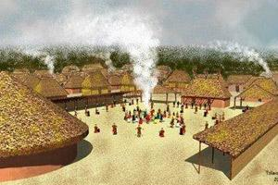 | Creek village | Morgan, S. K. (ed.). (2009). Creek Tribe. | http://www.facts4me.com
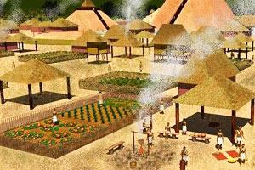 | Mound Site | Morgan, S. K. (ed.). (2009). Creek Tribe. | http://www.facts4me.com  Mound sites are a product of the Mississippian period and not of the later protohistoric period or early historic period. Therefore this is not specific for only Creek people but is specific for Mississippian or Southeastern Indian people who shared the Mississippian Culture.
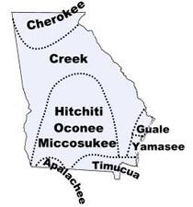 | Map of Creek Indians in Georgia | Morgan, S. K. (ed.). (2009). Creek Tribe. | http://www.facts4me.com
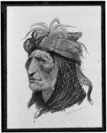 | The Creek Indian, head-and-shoulders portrait, facing left | The Creek Indian, Head-and-shoulders Portrait. 1906. Library of Congress Prints and Photographs Division Washington, D.C. 20540 USA. By Frederic Remington. | http://www.loc.gov/pictures/item/94505506/
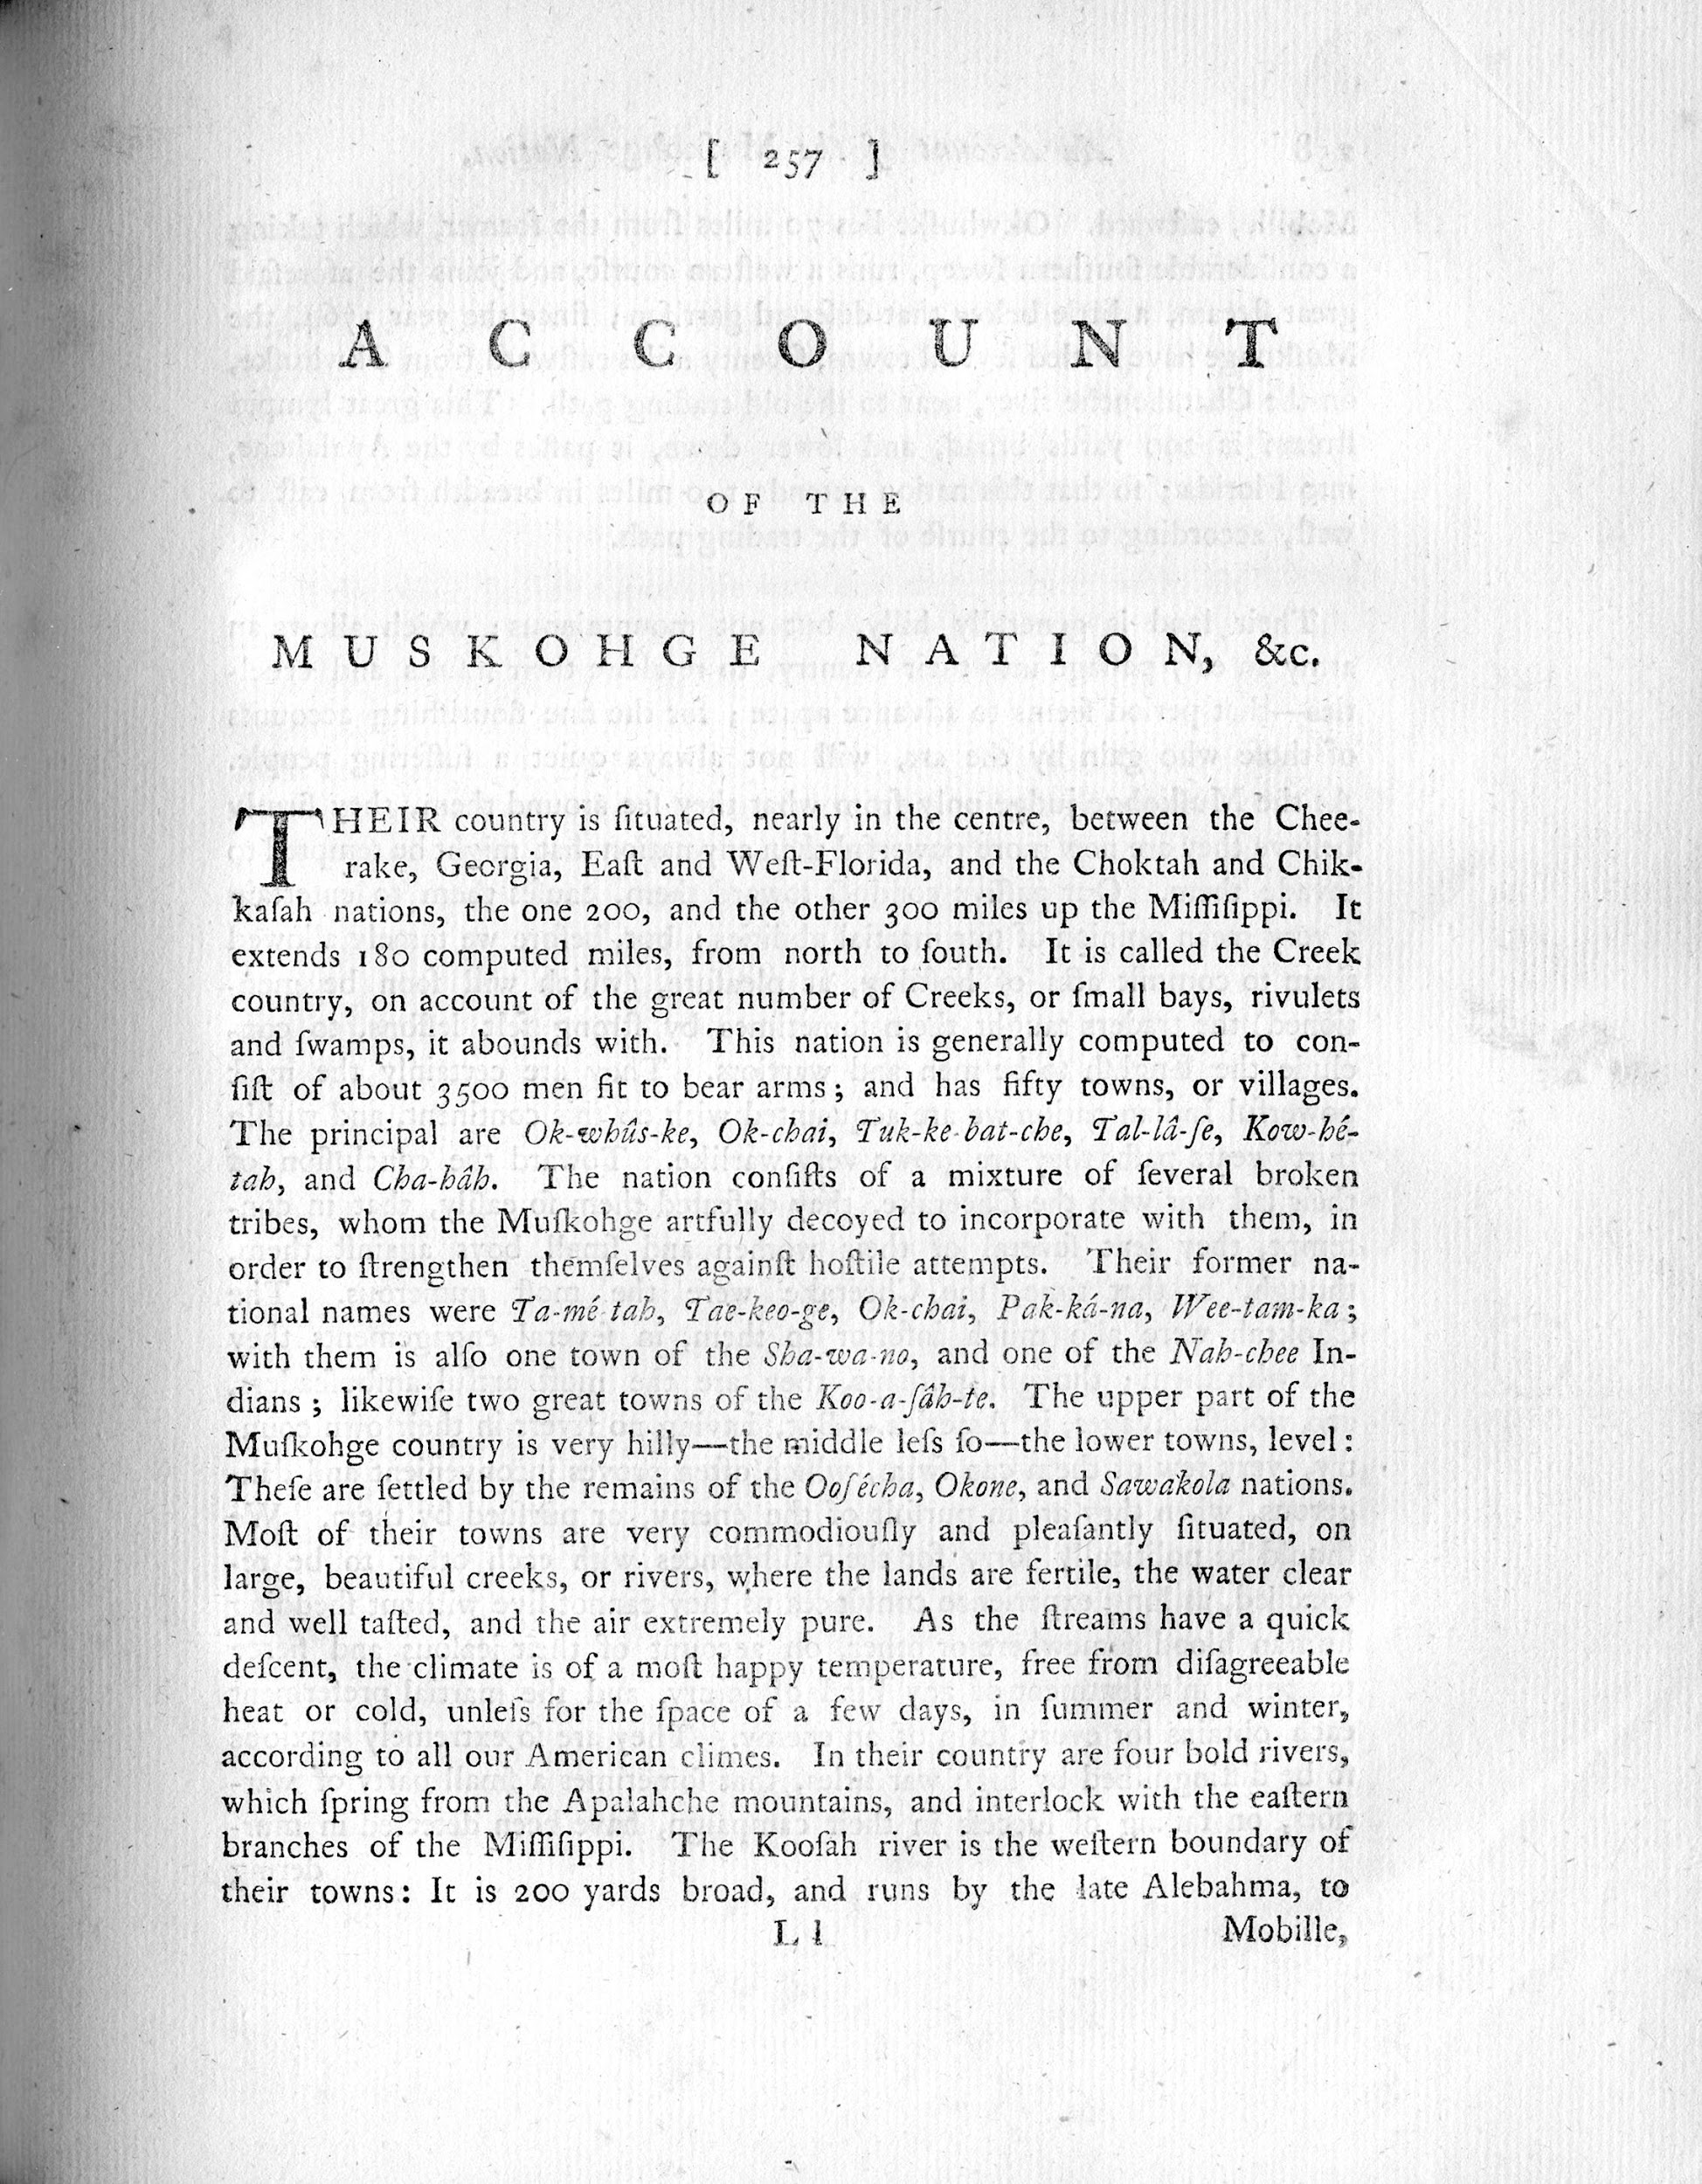 | The history of the American Indians containing an account of their origin, language, manners, religious and civil customs | Adair, J. (1775). American Indian Nations. Retrieved January 15, 2015, from http://memory.loc.gov/cgi-bin/query/D?fawbib:15:./temp/~ammem_DUT9:: | http://memory.loc.gov/cgi-bin/query/h?ammem/fawbib:@field(NUMBER+@band(icufaw+cbc0005))

Guiding Questions
What should students know or understand at the completion of the unit or lesson?
All Grade Levels:
- In what ways did the Southeastern Indians demonstrate that they were an advanced culture prior to the arrival of the Europeans?
- How and why did their material objects change as a result of the European settlers?
- What were some of the major characteristics of the lifestyles of the Southeastern Indians?
- How were the lives of the Southeastern Indians different from our preconceived notions?

Lesson Objectives:

- Students will be able to identify the Southeastern Indians living in Georgia before the colonists
- Students will be able to describe the homes and villages of the Southeastern Indians and compare and contrast them to those of other American Indians.

Indicators of Achievement
List all of the important indicators of achievement (important people, places, and events) and vocabulary that students will need to know at the conclusion of the lesson.
Muscogee Indians
Creek Nation/Confederacy (As labeled by the Europeans)
American Indians
European Explorer
Winter House
Palisades
Southeastern Indians

Sparking Strategy/Warm-Up
Sparking Strategy (Lesson introduction)
KWL
Using SMART Notebook, complete a KWL chart to assess prior knowledge.
Show video clip of either
- “Home Sweet Home” https://app.discoveryeducation.com/search?Ntt=southeast+indians
Or
- BrainPop Video: https://www.brainpop.com/socialstudies/culture/americanindians/
- Complete graphic organizer after the video clip

Lesson Procedures
In a numerical list provide a step by step outline of the lesson. Include questions you will ask the students and material you will use.
Outline (Steps also clarified in Guide Sheet)
- Ask students who the first Americans were. If they say the settlers, point out that the Southeastern Indians lived in our country long before the settlers arrived. Explain that there were two main groups of American Indians who lived in our area before the colonists arrived.
- Write the word Muscogee on the SMART Board. Tell students that they are going to be learning about the culture and history of the Muscogee Indians in this research project.
- Give each student a piece of white paper and ask them to do a quick drawing of what they think an American Indian or Southeastern Indian’s house used to look like. Students will probably draw a teepee as a typical Indian dwelling.
- Have them put their drawings aside and read descriptions of the Southeastern Indian’s villages as a class.
- Divide students into groups of three or four. Give each group a large piece of white craft paper and a group of crayons or markers. Show the slide on the SMART Board with the information about Southeastern Indian’s Villages and have students draw a Southeastern Indian’s Village based on the information shared.
- After groups have shared their drawings, show the images from http://www.facts4me.com

Differentiation
Think about students’ skill levels, intelligences, and learning styles.
For the gifted/advanced learner, have these students compare the Southeastern Indian’s Villages to those of other American Indians.

Evaluation
- Teacher observation
- Check group’s drawings of Southeastern Indian’s Villages

Citations (as needed)
http://www.muscogeenation-nsn.gov/
http://www.muscogeenation-nsn.gov/Pages/History/history.html
http://www.bigorrin.org/creek_kids.htm
http://www.indians.org/articles/creek-indians.html
https://www.brainpop.com/socialstudies/culture/americanindians/
http://www.aboutnorthgeorgia.com/ang/Creek_Nation
http://memory.loc.gov/cgi-bin/query/D?fawbib:15:./temp/~ammem_DUT9::
http://www.loc.gov/today/cyberlc/feature_wdesc.php?rec=4374

