Ivey Center for the Cultural Approach to History

Lesson Plan Template

Lesson Name
What is a Picture Worth?

Author(s)
Rob Grant and Toi Bone

Grades | Subject | Topic
9-11 | U.S. History, 9th or 11th Literature | Andersonville

Overview/Summary:
Students will view a picture from Thomas O’Dea’s depiction of Andersonville and interpret what they think is occurring in the image. They will share their interpretation with the class then write a verse of an I am poem based on a word they randomly select from a bag. These words are based on the images they analyzed. (NOTE: This would be completed after a discussion and readings about Andersonville Prison.)

Unit Name | Estimated Time Needed for Lesson
Civil War/U.S. History | 30 mins.

State/Common Core Standard, Grade Level & Description
Standard Number |  | Detailed description of each standard.
Common Core Standards for Reading in History/Social Studies
(11-12th)
L11-12RH2 |  | Determine the central ideas or information of a  primary or secondary source; provide an accurate summary that makes clear the relationships among the key details and ideas
L11-12 WHST2 |  | Write informative/explanatory texts, including the narration of historical events
Common Core Standards U.S. History
SSUSH9 |  | The student will identify key events, issues, and individuals relating to the causes, course, and consequences of the Civil War.
Common Core Standards 11th Grade American Literature
ELACC11-12SL1 |  | Initiate and participate effectively in a range of collaborative discussions(one-on-one, in groups, and teacher-led) with diverse partners on grades 11-12  topics, texts, and issues, building on others’ ideas and expressing their own clearly and persuasively.
ELACC11-12RI7 |  | Integrate and evaluate multiple sources of information presented in different media or formats (e.g., visually) as well as in words in order to address a question.
Common Core Standards
9-10th Grade Literature
ELACC9-10RI9 |  | Analyze seminal U.S. documents of historical and literary significance, including how they address related themes and concepts.
ELACC9-10W1c |  | Use words, phrases, and clauses to link the major sections of the text, create cohesion, and clarify the relationships between claim(s) and reasons, between reasons and evidence, and between claim(s) and counterclaims.
ELACC9-10W3d |  | Use precise words and phrases, telling details, and sensory language to convey a vivid picture of the experiences, events, setting, and/or characters.

NCSS Theme | Description
Theme Number | Detailed description of each NCSS theme
1 | Culture: Social studies programs should include experiences that provide for the study of  culture and cultural diversity
5 | Individuals, Groups, and Institutions: Social studies programs should include  experiences that provide for the study of interactions among individuals, groups, and institutions
6 | Power, Authority, and Governance: Social studies programs should include experiences that provide for the study of how people create and change structures of power, authority, and governance

The Cultural Approach Category | Description
Category | Detailed description of each Category that is a focus of this lesson.
Aesthetic | Looking at the artist’s interpretation of Andersonville will allow students to “see” what life was like for the Union soldiers.
Social | Within the group of prisoners were various regiments and companies. They tended to stick together and cared for one another whereas those who entered alone had a lesser chance at survival
Political | Analyzing the differences between the Raiders and the other prisoners will show that despite being part of the same Union, there was a “class” difference between the soldiers as they fought for survival
Economics | The prisoners who had money could buy items from the sutler and/or other prisoners. Also, due to the lack of money and supplies that the Confederates had, it greatly impacted the poor condition of the Union prisoners’ care.

Handouts/Materials/Textbook Pages/Web Links
List all of the materials in the lesson. List pages in textbooks and online links.
All Grade Levels:
- Copy of the Andersonville Prison artwork by Thomas O’Dea for each group as well as the large poster version.
- PPT presentation of the notes, questions, images, and instructions
- Posters and markers for the I Am Poems
- Andersonville Prison and American Prisoners of War
- “I AM” Poem template from ProjectExPreSS Student Guide

Image | Description | Citation | URL
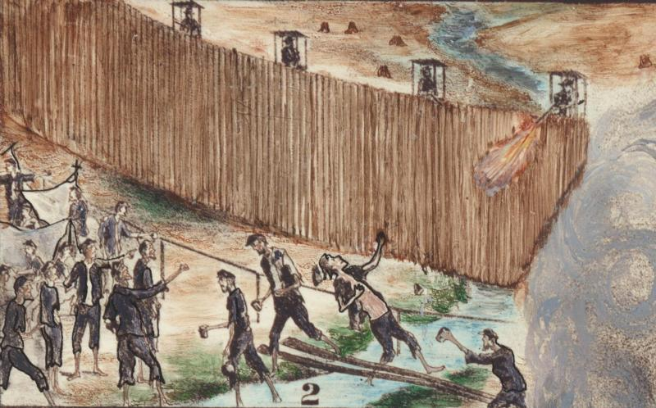 | #2 – Shot at the Deadline | National Park Service (www.nps.gov) | http://www.nps.gov/akr/photosmultimedia/photogallery.htm?id=8D47CC1C-1DD8-B71C-07AF929987E6B3A5
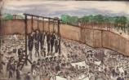 | #6 Execution of the Raiders, July 11th | National Park Service (www.nps.gov) | http://www.nps.gov/akr/photosmultimedia/photogallery.htm?id=8D47CC1C-1DD8-B71C-07AF929987E6B3A5
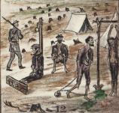 | #12 Mode of Punishment | National Park Service (www.nps.gov) | http://www.nps.gov/akr/photosmultimedia/photogallery.htm?id=8D47CC1C-1DD8-B71C-07AF929987E6B3A5
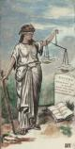 | #18 Justice, holding the scales | National Park Service (www.nps.gov) | http://www.nps.gov/akr/photosmultimedia/photogallery.htm?id=8D47CC1C-1DD8-B71C-07AF929987E6B3A5
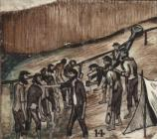 | #14 The Famous Providence Spring, Waiting for their Turn | National Park Service (www.nps.gov) | http://www.nps.gov/akr/photosmultimedia/photogallery.htm?id=8D47CC1C-1DD8-B71C-07AF929987E6B3A5
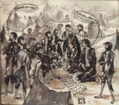 | #13 Distributing Rations | National Park Service (www.nps.gov) | http://www.nps.gov/akr/photosmultimedia/photogallery.htm?id=8D47CC1C-1DD8-B71C-07AF929987E6B3A5
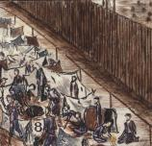 | #8 Digging for a Tunnel | National Park Service (www.nps.gov) | http://www.nps.gov/akr/photosmultimedia/photogallery.htm?id=8D47CC1C-1DD8-B71C-07AF929987E6B3A5

Guiding Questions
What should students know or understand at the completion of the unit or lesson?
All Grade Levels:

- Students should understand that art can have an impact on one’s understanding of historical events.
- Students should understand that a stressful (survival type) situation can adversely affect one’s actions.
- Students should analyze a situation from more than one perspective to get full understanding of a historical event.

Additional Questions:
- How does Thomas O’Dea’s depiction of life in Andersonville impact your understanding of this part of Civil War history?
- Why were the prisoners in the Andersonville prison treated as they were?
- Why did the Raiders turn on their fellow man? What does that say for the social relationships between these men who fought side by side during the battles?
- How do our personal experiences affect how we see an event (both students and O’Dea)?

Indicators of Achievement
List all of the important indicators of achievement (important people, places, and events) and vocabulary that students will need to know at the conclusion of the lesson.
- Understanding of the events and conditions of the Andersonville prison camp
- Understanding of who Thomas O’Dea was and about lithography

Assessment Strategies
Describe the assessments that will be used during the unit.
For this activity, students will be assessed by their comments and responses about the images they analyzed as well as the I am poem in how well they convey the concept they select.

Teaching Strategies
5 min | Review of Andersonville  & Background about Thomas O’Dea’s artwork | 5 min | Sharing and Discussion | 10 min | I Am Poem Activity in groups  Sharing of I Am Poems
5 min | Analysis of images from the artwork |  |  | 5 min | Conclusion/Summary
 |  | Describe all of the teaching strategies that you will be using in this lesson. In the squares calculate the percentage of the lesson that the strategy will take. For example in an hour lesson, lecture should take no more than 25% (15 min) of the lesson.

Sparking Strategy/Warm-Up
Sparking Strategy (Lesson introduction)
1. Have students create a word splash of words and phrases that come to mind about Andersonville prison and how the prisoners were treated. (Students can utilize this list later for their poems.)
2. Review what we have previously learned about Andersonville and the treatment of prisoners.

Lesson Procedures
In a numerical list provide a step by step outline of the lesson. Include questions you will ask the students and material you will use.
Outline (Steps also clarified in Guide Sheet)
1. Put students into groups of fours.

2. Assign each groups an image to interpret and be prepared to discuss what is occurring
(5 W’s & How).

3. Have each group discuss their interpretation of the images.

4. I am Poem
- Each group will get a mini-poster that contains a stanza of the formula poem.
- They will draw a word from a bag then complete the poem through the perspective of that word.
- Students will share their stanza with the class.

Differentiation
Think about students’ skill levels, intelligences, and learning styles.
- Assign a specific picture to students who would struggle with the activity and give guided notes/ideas to assist their responses. (struggling/lower level students)
- Have students research other artwork from Andersonville and compare/contrast with O’Dea’s piece. (advanced students)

Summarizing Strategies/Synthesizing Activity
The strategies to allow students to summarize what they learned in the lesson.
I Am Poem: Students will draw a word from a bag (deadline, spring, tunnel, Raiders, prisoners, guard, prison, shebang) that represents either a person or object from Andersonville. They are to create a stanza of the poem to demonstrate their understanding of what occurred at the prison and the different perspectives.

Evaluation
- Critical Thinking Questions: Do you think this artist depiction of Andersonville is a true representation of what it was like? Do you think O’Dea might have embellished or exaggerated the images because he was a prisoner? Do you think his taking 5 years to complete it could have affected how he represented the details?

Citations (as needed)

