Historical Investigation of ________________________________________________________
By: _______________________________________________
- Use the Categories of Institutions graphs to complete the Historical Investigation Form.
- Use the following websites to help you research:
  - www.loc.gov
  - www.ducksters.com
  - www.mrnussbaum.com
  - www.socialstudiesforkids.com
  - www.biography.com
- Present your research to teacher.
- With teacher, analyze and organize information into categories using Categories of Institutions handout.
- Design and Construct game board using information found to generate questions.
Game Board “MUST HAVES”
- Title/Name
- Categories- at least five questions in each category
- Social-Red
- Intellectual-Blue
- Political-Purple
- Vocabulary-Black
- Dates of Topic
- Location(s) of Topic
- Picture of Topic
- Written Rules
- Name of Designers
Game Board Layout Examples
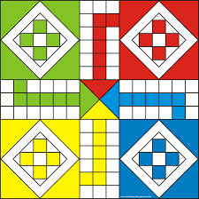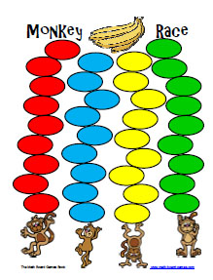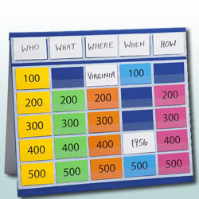

Name: ________________________________
Frederick Douglass: Game Board Prep

Before designing the game board about Frederick Douglass, organize the following statement into these game categories, Social/Intellectual/Political. The statements may fit multiple categories.
Statement | Category
Frederick Douglass’ (born Frederick Baily) mother was a slave, so he was born a slave in 1818.
Slaves were not allowed to stay with their families when working on plantations. Frederick seldom saw his mother and felt so sorrow when she died when he was 10.
Around the age of 12, he moved to Baltimore, where he learned to read and write with little help. His owner’s wife taught him until her husband caught her and scolded her.
Frederick Douglass read about slavery in newspapers and books. He felt the need to help so he began teaching other slaves to read until he was caught by slave owners.
His punishment was being sent to a farm with a cruel slave owner, called the slave breaker. Frederick wanted freedom more than ever and to help other slaves.
He tried to escape to the north several times before succeeding. After disguised himself as a sailor with freedom papers, he escaped to New York by train in 1838.
Anna Murray helped Frederick escape. The two fell in love and were married in Massachusetts where they both took on the last name Douglass.
Frederick found his calling in public speaking. He spoke to crowds often about the inhumanity of slavery.
At the urging of William Lloyd Garrison, Douglass wrote and published his first autobiography, Narrative of the Life of Frederick Douglass, an American Slave, in 1845.
Douglass fled to Britain and Ireland after his book became a best seller. He befriended several Englishmen who paid about $800 for his freedom in America.
The North Star was one of the newspapers he started after returning to America.

In 1863, Douglass conferred with President Abraham Lincoln regarding the treatment of black soldiers and recruited soldiers for the 54th Massachusetts Regiment.
After the Civil War, Frederick worked with President Andrew Johnson on black suffrage, the right to vote.
Frederick Douglass was the first black man nominated for Vice President on the Equal Rights Party in 1872. He was nominated without his knowledge and did not campaign.
Douglass served the US by being appointed to offices by President Hayes, President Garfield, President Harrison, and President Grant.
in 1895, Douglass died after attending a meeting with the National Council of Women in Washington D.C.

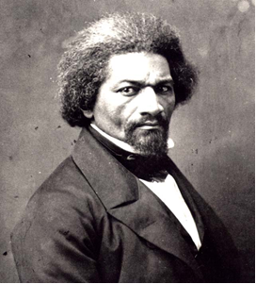
Vocabulary for Human Rights
Abolitionist-a person who wants to end slavery
Civil rights-rights protected by laws
Conductor-a person who helped people escape to freedom on the Underground Railroad
Conscience-an inner sense of right and wrong
Enslaved-forced to work without pay
Expression-the ability to speak and write
Freedom-not being controlled by someone else
Justice-equal treatment under the law
Liberty-freedom
Prejudice-a strong feeling or opinion formed unfairly or without knowing all the facts
Rights-freedoms that are protected by a country's laws
Slavery- a cruel system in which someone legally owns or controls another person
Underground Railroad-secret network of people and hiding places to help slaves escape to freedom

