Ivey Center for the Cultural Approach to History

Lesson Plan Template

Lesson Name
Lynching in Columbus & Marietta GA

Author(s)
Darlene Cook

Grades | Subject | Topic
8 | GA Studies

Overview/Summary:
Lesson over the lynching of Leo Frank, Jesse Slayton, and Will Miles.

Unit Name | Estimated Time Needed for Lesson
 | 4 50 minute class periods

State/Common Core Standard, Grade Level & Description
Standard Number |  | Detailed description of each standard.
8th Grade GPS
SS8H7 |  | The student will evaluate key political, social, and economic changes that occurred in Georgia between 1877 and 1918.  a. Evaluate the impact the Bourbon Triumvirate, Henry Grady, International Cotton Exposition, Tom Watson and the Populists, Rebecca Latimer Felton, the 1906 Atlanta Riot, the Leo Frank Case, and the county unit system had on Georgia during this period.

NCSS Theme | Description
Theme Number | Detailed description of each NCSS theme

The Cultural Approach Category | Description
Category | Detailed description of each Category that is a focus of this lesson.
Political | - Analyze the political structure of the South.  - Were the courts and lawmakers fair?
Social | - Describe the social differences between whites and minorities.  - Why were (are) people treated differently?
Religion | - Examine different religious groups.  - What role did the synagogues and churches play?
Intellectual | - Examine the intellectual differences between the different groups of people.  - What type of communication separated /united the races/ethnic groups?
Economic | - Examine the economic opportunities between 1877 and 1918.  - What types of jobs were available for minorities?
Aesthetic | - Identify some aesthetics of the South.  - How did society define beauty?

Handouts/Materials/Textbook Pages/Web Links
List all of the materials in the lesson. List pages in textbooks and online links.
8th Grade:
- Smart Board

- Document Camera

- Markers/Colored Pencils

- Textbook: Georgia and the American Experience

- 11x17 paper

Additional Sources:
- Matthew H. Bernstein, Screening a Lynching: The Leo Frank Case on Film and Television (Athens: University of Georgia Press, 2009).

- W. Fitzhugh Brundage, Lynching in the New South: Georgia and Virginia, 1880-1930 (Urbana: University of Illinois Press, 1993).

- Leonard Dinnerstein, The Leo Frank Case (1968; reprint, Athens: University of Georgia Press, 1999).

- Harry Golden, A Little Girl Is Dead (Cleveland, Ohio: World, 1965).

- Nancy MacLean, "The Leo Frank Case Reconsidered: Gender and Sexual Politics in the Making of Reactionary Populism," Journal of American History 78 (December 1991): 917-48.

- David Mamet, The Old Religion (New York: Free Press, 1997).

- Steve Oney, And the Dead Shall Rise: The Murder of Mary Phagan and the Lynching of Leo Frank (New York: Pantheon, 2003).

- Dinnerstein, Leonard. "Leo Frank Case." New Georgia Encyclopedia. 05 June 2014. Web. 21 July 2014.

- William Breman Jewish Heritage Museum: Seeking Justice: The Leo Frank Case Revisited

- Georgia Public Broadcasting: Georgia Stories: "The New South and Leo Frank"

- Georgia Historical Society: Leo Frank Lynching

- Georgia Historical Society: Steve Oney Papers, 1896-2009

- Emory Libraries: Leo Frank Collection, 1915-1986

- PBS: The People v. Leo Frank

- Georgia's Virtual Vault: Executive Clemency Decision by Gov. John M. Slaton

- WABE: One on One with Steve Goss: 100 Years After: Leo Frank Case Still Raises Questions

- http://www.ledger-enquirer.com/2013/06/01/2526359/memorial-service-remembers- two.html

- http://www.ledger-enquirer.com/2013/05/31/2525213/lynching-at-the-corner-of-broadway.html

Image | Description | Citation | URL
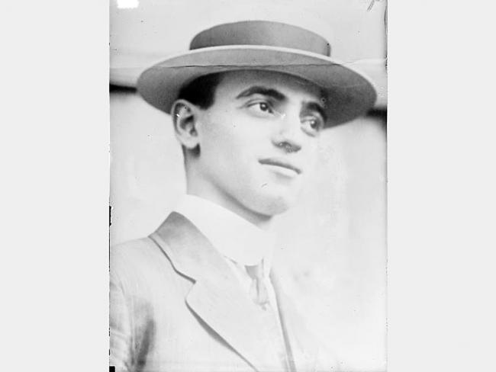 | Leo Frank | New Georgia Encylopedia | http://www.georgiaencyclopedia.org/articles/history-archaeology/leo-frank-case
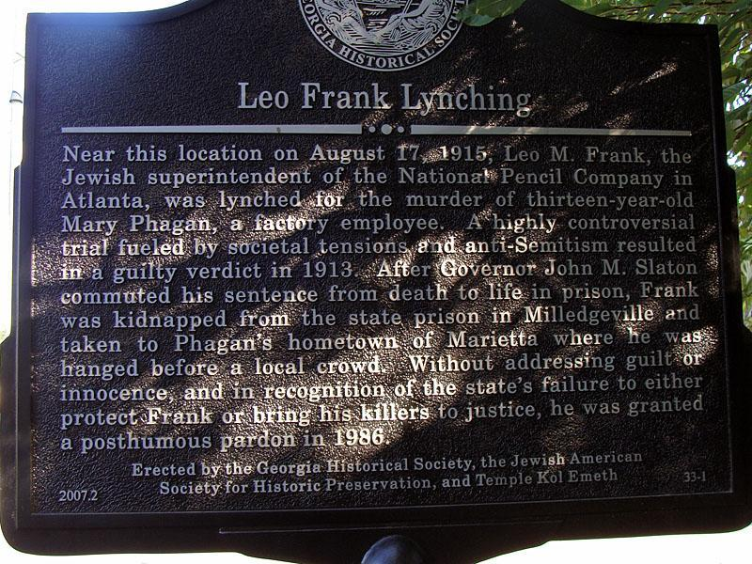 | Leo Frank Memorial Marker | Courtesy of Darlene Cook | N/A
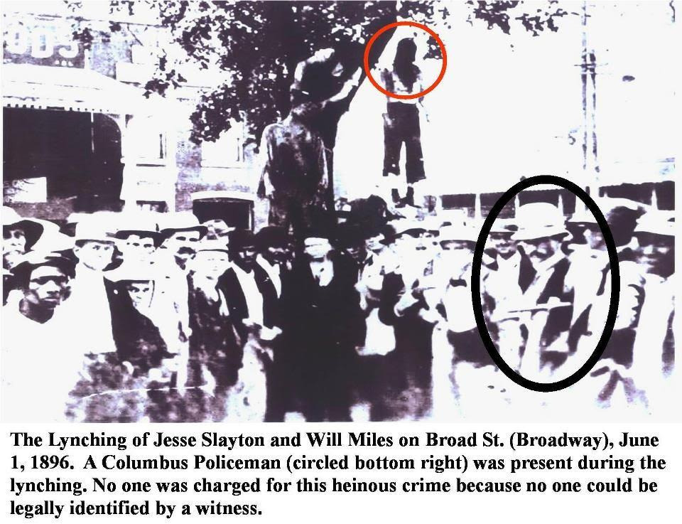 | Lynching of Jesse Slayton and Will Miles | Courtesy of Dr. Richard Gardiner | N/A
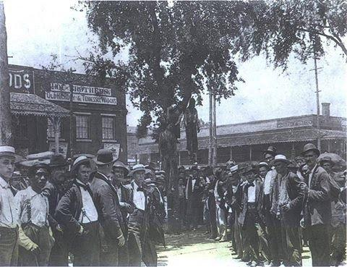 | Lynching of Jesse Slayton and Will Milies | Courtesy of Dr. Richard Gardiner | N/A

Guiding Questions
What should students know or understand at the completion of the unit or lesson?
All Grade Levels:

- Was Justice Served in the case of Leo Frank, Jesse Slayton, and Will Miles?

- Do you think each received a fair trial?

- Was John Slaton a hero?

Additional Questions:
- N/A

Indicators of Achievement
List all of the important indicators of achievement (important people, places, and events) and vocabulary that students will need to know at the conclusion of the lesson.
- Vocabulary: Lynching, Mob, Perforated, Deliberate, Assault, Humanity, Inquest, Discrimination, Prejudice

- Performance Tasks for Gifted/Advanced: You were a witness to either the lynching of Jesse Slayton and Will Miles or Leo Frank. Describe your thoughts about the event and take a stance for or against the victims. Do you think each received a fair trial? Was John Slaton a hero? Write a two page essay comparing and contrasting the differences and similarities of each case. You will be assessed on your ability to communicate effectively as to why you made your decision.

- Performance Tasks for Tiered Assignments/Differentiated Activities: Lower level students will use scaffolding techniques for all data charts and graphic organizers. Lower level students will be provided a copy of the Power point so they can be better prepared for the presentation. Performance Task: Create a story map with pictures to describe events detailed in primary sources.

Assessment Strategies
Describe the assessments that will be used during the unit.
- Graphic Organizers –DBQ

- KWL Chart
  - 4 facts I already know
  - 3 things you’ve learned
  - 2 questions you have
  - 1 thing you understand now

Lesson Procedures
In a numerical list provide a step by step outline of the lesson. Include questions you will ask the students and material you will use.
Outline (Steps also clarified in Guide Sheet)
1. Students will be introduced to content information surrounding the Leo Frank lynching and the Jesse Slayton and Will Miles lynching.
- The content sheets are attached as a word document.

2. Students will break up into groups and evaluate the primary source documents in the content word document packet.

3. Gifted Student will complete the performance tasks listed above. Traditional Students will complete the separate performance tasks listed above.

4. Once the performance tasks have been completed, students will be assessed over their lesson/content information.
- KWL Chart:
- 4 - facts I already knew
- 3 – things you’ve learned
- 2 – questions you have
- 1 – I understand now!

