MICV Handout 2

La Royale: Cotillion dance for four couples in a square formation
Le Grand Rond
"The first and third Gentlemen take the Ladies on their Left, cross Corners and change places, then the second and fourth Gentlemen do the same
The four Ladies hands Round to their places, then the four Gentlemen do the same"
From Giovanni-Andrea Gallini's Collection of Forty-four Cotillions, 1770.
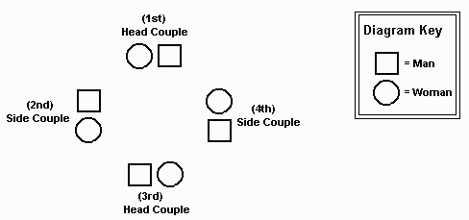
Before the dance begins, designate head couples, who face the top and bottom of the room, and side couples, who face the sides of the room (refer to diagram above).
[Important note: The 3 FIGURE portions of the dance are exactly the same each time. The 3 portions of the dance noted as CHANGES have different steps.]

Music  Strain | Dance  Counts
 |  | FIRST CHANGE: "La Grand Rond"
A | 16 | All join hands in a large circle and chasse or walk clockwise to the left (16).
A | 16 | Circle back to place (16).
 |  | FIGURE:
B | 16 | Head gentlemen take both hands with side ladies on their left [first man takes fourth lady, third man takes second lady]. These couples chasse or walk sideways across the set to opposite places, then turn halfway so that the ladies end in the side positions and the men are in the head positions (8).  Side gentlemen repeat with head ladies [second man takes first lady, fourth man takes third lady] (8).
B | 16 | Ladies step into to the circle and join hands (2) then circle to the left back to their original positions (6).  Men do the same (8).
 |  | SECOND CHANGE: "Set and Turn"
A | 16 | All face partners do two setting steps by stepping to the right and close then to the left and close (4) and repeating (4), then turn partner by the right hand (8).
A | 16 | All face partners do two setting steps by stepping to the right and close then to the left and close (4) and repeating (4), then turn partner by the left hand (8).
 |  | FIGURE:
B | 16 | Head gentlemen take both hands with side ladies on their left [first man takes fourth lady, third man takes second lady]. These couples chasse or walk sideways across the set to opposite places, then turn halfway so that the ladies end in the side positions and the men are in the head positions (8).  Side gentlemen repeat with head ladies [second man takes first lady, fourth man takes third lady] (8).
B | 16 | Ladies step into to the circle and join hands (2) then circle to the left back to their original positions (6).  Men do the same (8).
 |  | THIRD CHANGE: "Grand Chain"
A  A | 16  16 | Everyone does grand chain moving in a circular path by weaving right hands and left hands alternately. To begin give right hand to partner and walk forward, passing by partner (4), give left hand to next person and walk by (4), then right hand to third person (4) and so on until everyone reaches original positions. [Please note: This "Grand Chain" continues for a total of 32 beats.]
 |  | FIGURE:
B | 16 | Head gentlemen take both hands with side ladies on their left [first man takes fourth lady, third man takes second lady]. These couples chasse or walk sideways across the set to opposite places, then turn halfway so that the ladies end in the side positions and the men are in the head positions (8).  Side gentlemen repeat with head ladies [second man takes first lady, fourth man takes third lady] (8).
B | 16 | Ladies step into to the circle and join hands (2) then circle to the left back to their original positions (6).  Men do the same (8).
Published on Colonial Williamsburg Teacher Community (http://teachers.history.org)

