MICV Handout 3

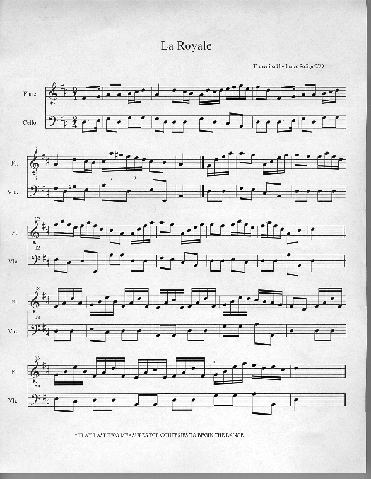
Published on Colonial Williamsburg Teacher Community (http://teachers.history.org)

